WH&S Management Plan

Purpose

This purpose of this plan is to:

* Minimize and manage areas of the workplace that may present danger of harm to workers
* Have well designed ergonomic work zones

This plan will assist Electronic Arts in meeting its obligations in accordance with work health and safety legislation.

This plan applies to all Electronic Arts’ employees and to other persons at risk from work carried out at Electronic Arts’ workplaces. Failure to comply with the requirements of this Plan may lead to disciplinary action.

Work Health and Safety (WHS) Policy

The Statement of Commitment and the Implementation of Policy Commitment provide the overarching direction Electronic Arts will follow in pursuit of workplace health and safety outcomes. These commitments are:

**Statement of Commitment**

Electronic Arts is committed to providing a workplace that enables all work activities to be carried out safely. We will take all reasonably practicable measures to eliminate or minimize risks to health, safety and welfare of workers, contactors, visitors, and anyone else who may be affected by our operations.

We are committed to ensuring we comply with the *Work Health and Safety Act 2011* (the Act). We will also comply with any other relevant legislation, applicable Codes of Practice and Australian Standards as far as possible.

**Implementation of Policy Commitment**

Electronic Arts is committed to ensuring, so far as is reasonably practicable, the health and safety of its works while they are at work, and that the health and safety of other persons is not put at risk from our operations. This will be achieved by:

* providing a safe working environment
* providing each worker with a professionally designed ergonomically sound work environment

Duty of Care

A Person Conducting a Business or Undertaking (PCBU) has the primary duty of care to ensure:

* to provide a safe work environment for all workers
* to provide all necessary information to the workers about how to work safely in their environment

Electronic Arts is a PCBU.

Responsibilities

**Managers and Leaders**

Managers and leaders are responsible for providing a workplace that is, as far as reasonably practicable, a safe and healthy workplace for workers and visitors, in particular in the areas of their control. This includes:

* modelling health and safety leadership
* demonstrating a commitment to good health and safety performance
* Providing adequate training to the workers on how to safely interact with their work environment
* Providing ergonomically sound workstations

**Workers**

Workers must take reasonable care for their own health and safety while they are at work, and take reasonable care that their acts or omissions do not adversely affect the health and safety of other persons.

On a day to day basis, this includes:

* ensuring their own personal health and safety, and that of others in the workplace
* complying with any reasonable directions (such as safe work procedures, wearing personal protective equipment) given by management that relates to health and safety
* not misusing or interfering with anyth8ing provided in the interest of health and safety

It is acknowledged that, in accordance with the Act, a worker may cease, or refuse to carry out work if they have a reasonable concern the work would expose the worker to a serious risk to their health and safety.

**Contractors**

Contractors, sub-contractors and self-employed persons are defined as “workers” under the WHS Act if they carry out work in any capacity for Electronic Arts. They are required to:

* work safely and to include the safety of the business’ staff and visitors in their safety plans
* comply with the requirements of the WHS legislation

**Health and Safety Experts**

The following is a list of nominated workplace health and safety experts, who may be called on to assist with any aspect of this workplace health and safety management plan.

* Heath Palpatine

WHS Risk Assessment:

The purpose of any WHS risk assessment is to ensure that, for any identified hazards, appropriate control measures are implemented in order to protect workers, contractors and visitors from risks to their health, safety and welfare.

Control measures for WHS hazards should be implemented as required using the following hierarchy of control, in order of preference these measures relate to:

* elimination (removal of the hazard)
* substitution (substitute the hazard for something which is less hazardous e.g. replace a hazardous chemical with one within is not hazardous)
* isolation (isolate the hazard from people e.g. place a noisy piece of equipment in another location)
* engineering (e.g. guarding on machinery)
* administrative (e.g. provision of training, policies and procedures, signage)
* personal protective equipment (e.g. use of hearing, eye protection, high visibility vests).

Outcomes of risk assessments will be documented and the control measures reviewed at least annually or earlier should a task or activity be the subject of a WHS incident or a change of process or requirement. Current risk assessments will ensure that Electronic Arts achieves the goal of eliminating or minimising the risk workers may be exposed to.

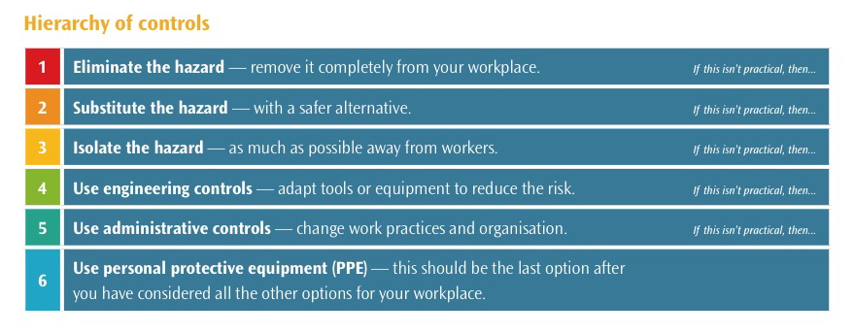

Hazard and Risk Assessment:

|  |  |  |  |  |  |
| --- | --- | --- | --- | --- | --- |
| IMPACT | LIKELIHOOD | | | | |
| Rare (1) | Unlikely (2) | Possible (3) | Likely (4) | Almost Certain (5) |
| Catastrophic (A) | M | M | H | C | C |
| Major (B) | L | M | M | H | C |
| Moderate (C) | L | M | M | M | H |
| Minor (D) | L | L | M | M | M |
| Insignificant € | VL | VL | L | L | M |

|  |  |
| --- | --- |
| Risk level | Required action |
| Critical | Act immediately:  The proposed task or process activity must not proceed. Steps must be taken to lower the risk level to as low as reasonably practicable using the hierarchy of risk controls. |
| High | Act today:  The proposed activity can only proceed, provided that:  (i) the risk level has been reduced to as low as reasonably practicable using the hierarchy of risk controls;  (ii) the risk controls must include those identified in legislation, Standards, Codes of Practice etc.  (iii) the risk assessment has been reviewed and approved by the Supervisor and  (iv) The supervisor must review and document the effectiveness of the implemented risk controls. |
| Medium | Act this week:  The proposed task or process can proceed, provided that:  (i) the risk level has been reduced to as low as reasonably practicable using the hierarchy of risk controls;  (ii) the risk assessment has been reviewed and approved by the Supervisor. |
| Low | Act this month:  Managed by local documented routine procedures which must include application of the hierarchy of controls. |
| Very Low | Keep a watching brief:  Although the risk level is low the situation should be monitored periodically to determine if the situation changes. |

|  |  |  |  |
| --- | --- | --- | --- |
| Hazard | Consequence | Likelihood | Risk Level |
| Tripping hazards | Stumbling, falling over | unlikely | medium |
| The computer screen | Eye strain | likely | Low - medium |
| Co-workers | Stress, annoyance, frustration | likely | low |
| Chairs | Back pain, back strain | likely | low |
| stairs | Falling down, tripping up | likely | medium |
| Drinks around computers | Destroying computers and keyboards | unlikely | medium |
| bullying | Stress, low self esteem | unlikely | high |
| tables | Nudging or bumping into edges and hurting your legs/arms | unlikely | low |

|  |  |
| --- | --- |
| Workplace location: | Wattle Street, Ultimo |
| Name of person conducting assessment: | Ben Alder |
| Date: | 22/3/2017 |

|  |  |  |  |  |  |  |  |  |  |  |
| --- | --- | --- | --- | --- | --- | --- | --- | --- | --- | --- |
| S | Spot the hazard | | A | Assess the risk | F | Fix the problem | | | E | Evaluate results |
| Identify the work task or activity | | What are the hazards associated with each activity or the steps in each activity | Is the risk associated with the hazard low, moderate, significant or high? | | If the risk is deemed unacceptable for the task, what will be done to reduce or remove the risk? | | By whom? | By when? | Go through the first 3 steps again to ensure risk levels are now at an acceptable level | |
| Revised risk level | |
| Excursion | | Loss of workers | low | | Have phones to be contactable at all times | | All involved | ASAP | Very low | |
| Working on a computer | | Electrocution, cuts | moderate | | grounding wires to be utilised and care is to be taken | | IT department | That day | Low | |
| Eating/Drinking | | Destruction of equipment | moderate | | Eat and drink away from computers | | All workers | Every day | Low | |
| Computer isn’t working | | Work stopped | low | | Call IT support | | IT department | That day | Very low | |

Training Plan for Workers:

Electronic Arts is committed to providing appropriate training to ensure workers have the skills and knowledge necessary to fulfil their WHS obligations. WHS training is a fundamental requirement for Electronic Arts to achieve a safe workplace.

The following induction checklist should be used in conjunction with the general induction training program for workers to ensure that all new workers are aware of the WHS systems, policies and procedures in place within Electronic Arts.

|  |  |
| --- | --- |
| Workplace: Electronic Arts | |
| Date: 21/3/2017 | Completed by: Ben Alder |

|  |  |  |  |  |
| --- | --- | --- | --- | --- |
| Control measures | What training is required? | Who is to be trained? | How? | Date completed |
| Computer maintenance | Extensive knowledge of computer hardware | IT department | External training | 23/3/2017 |
| Administrative computer work | Extensive knowledge of computer hardware, and have years of experience working on hardware | Head of the IT department | External training and previous years of work experience | 23/3/2017 |
| Fire extinguishers | Safety induction | All staff | Introduction to job course | 23/3/2017 |
| Workstation Conditions | n/a | All staff | To be checked by management staff | 23/3/2017 |
| Emergency evacuation | Safety induction | All staff | Safety induction | 23/3/2017 |